Austin Health Changes to Safety Reporting for Adverse Patient Safety Events

* The Patient Safety and Clinical Excellence Unit has updated the [Adverse Patient Safety Events Manual](https://austinhealth.sharepoint.com/:b:/r/sites/OPPIC/GuidelinePublished/Adverse%20Patient%20Safety%20Event%20Manual.pdf?csf=1&web=1&e=xaf0y6), which can now be found on OPPIC.
* **Safety Reporting for research has been added as an appendix to the manual.**
* [**RiskMan**](https://riskman.austin.org.au/) can now be used to report all safety incidents.

|  |  |  |  |
| --- | --- | --- | --- |
| **Theme** | **Stop** | **Start** | **Continue** |
| **Safety reporting** | Stop submitting your safety reports via email and ERM. | Start using [RiskMan](https://riskman.austin.org.au/) to report all safety issues to the Discovery & innovation Unit.  The report can be downloaded and submitted to,   * TGA * HREC * Sponsor | For safety incidents occurring outside of Austin Health, report these via our [Safety Report Forms](https://www.austin.org.au/page?ID=4290). |



|  |  |
| --- | --- |
| **Who does this change affect?**  This change impacts those who are in engaged in any aspect of research.  **Here are the roles we’ve identified this change will impact:** | |
| **Research teams in local areas**   * Principal Investigators & Associate/Co Investigators * Local Research Managers, Coordinators, Nurses, Ethics Submission Specialists   **Corporate Services**   * Partnering Departments   (Pharmacy, Radiology, Pathology, MIT, Allied Health) | **Sponsors & Research Partners**   * Sponsors (Commercial, University, Medical Research Institute, Networks, Alliances) * The good news is this change doesn’t affect our research agreements. We’ve changed our Unit name, but the legal name remains as Austin Health.   **Divisions**   * Divisional Directors * Divisional Managers |

**RiskMan Reporting for Research Incidents:**

**Context**:

The way RiskMan Incidents has been set-up is to capture any incident related to a patient using the well-defined clinical governance system that is universal in Australia. This approach means the person entering the incident doesn’t need to understand the NHMRC Safety Reporting guidelines. Instead, if there is a flag on the patient’s medical record that they are in a clinical research/trial, this triggers an extra layer of reporting. This system also means Researchers shouldn’t try classifying events using the NHMRC safety reporting system. Researchers should prioritise immediate reporting through the existing clinical governance processes. As the incident is managed/investigated, the ISR rating will drive the types of NHMRC incident rating. This concept is important to understand when you are reporting your research incidents.

For the patient at your Health Service, you should be entering unexpected serious adverse events that are harmful, into RiskMan Incidents. This is because it is **good clinical management** to list these events; we shouldn’t choose convenience or Sponsor preferences over good clinical governance management.

**The reports are sent directly to:**

* The ward managing the incident
* The Research Regulatory Office of the Health Service (e.g., Research Office/Research Governance Office/Discovery & Innovation Unit)

**When research is ticked, the responsibilities of the Research Regulatory Office and researchers is as follows:**

* Research Regulatory Office to help researchers manage any mandatory reporting to the TGA, Sponsor & HREC and provide quarterly reporting to the Board on the safety profile of its clinical research/trials patients.
* It is the responsibility of the Principal Investigator to attached evidence of any ISR1 or ISR2 events to the Sponsor and/or TGA and/or Coordinating Principal investigator. Reporting must be within the NHMRC timeframes.

**What to report:**

* Safety events named in the research protocol that are required to be reported.
* Safety/ clinical participant events that are not listed in the research protocol and are unexpected.

|  |  |
| --- | --- |
| **For Austin Health Led Research** | **For Externally Approved Research** |
| As lead site and HREC, report events for all participating sites. | Report via [Safety Report Forms](https://www.austin.org.au/page?ID=4290) for all Austin Health participant events. |



**What not to report:**

* Line listings of incidents occurring at sites outside of Australia. This can instead be submitted as part of the annual Progress Report or annual Safety/ Clinical Report to provide a picture of the global progress of a research project.
* Safety updates that do not trigger any changes in the research project design, safety or the continued ethical acceptance of the research project.

**Response from HREC:**

Incidents required to be reported to HREC should be reported via RiskMan (if Austin Health incident) or Safety Reporting Form (if occurring at another site) and will be scheduled for review as per the HREC meeting schedule. The Discovery & Innovation Unit will relay the response via email.

**NOTE:**

* All research incidents will not receive a response. However, all incidents must be reported on RiskMan or Safety Report Forms for safety and quality.
* Incidents requiring reporting as per NHMRC guidelines will be processed and will receive officially correspondence from the Discovery & Innovation Unit.

|  |  |  |  |  |
| --- | --- | --- | --- | --- |
| Incident Severity Rating (ISR) | NHMRC rating | NHMRC Definition | NHMRC Reporting | |
| **Austin Health Led Research** | **Externally Approved Research** |
| * ISR 1   Death or life-threatening,  permanent injury/harm. | * Significant Safety Issue (SSI). * Unexpected Serious Adverse Event leading to death, is life-threatening or causes permanent injury/harm. * Any incident/correspondence that means the project is halted or terminated for safety reasons. | An **SSI** is an adverse event that affects the safety of participants or materially impacts the continued ethical acceptability or conduct of the trial.  SSIs trigger other actions such as reporting of an urgent safety measure, an amendment, temporary halt or early termination of the trial. | **Report via RiskMan.**  **Urgent Safety Measure:**  within 72 hours.  **Serious injury/ fatality:**  Within 7 calendar days  **Notification of amendment:**  Within 15 calendar days.  **Temporary halt:**  Within 15 calendar days.  Report to:   * TGA * Research Office/ HREC * Sponsor | **Report via Safety Report Forms.**  **Urgent Safety Measure:**  within 72 hours.  **Serious injury/ fatality:**  Within 7 calendar days  **Notification of amendment:**  Within 15 calendar days.  **Temporary halt:**  Within 15 calendar days.  Report to:   * TGA * Research Office/ HREC * Sponsor |
| * ISR 2   Moderate harm,  hospitalisation. | * Unexpected Serious Adverse Event leading to moderate harm or hospitalisation. * Serious Breach that has led to moderate harm or hospitalisation. * Any incident/correspondence that means the project has been amended to meet new safety requirements. | A **Serious Adverse Event** is defined as any untoward medical occurrence in a clinical trial or other clinical research project that:· results in death; is life-threatening; requires in-patient hospitalisation or prolongation of existing hospitalisation; results in a persistent or significant disability/incapacity; is a congenital anomaly/birth defect; or is a medically important event or reaction.  A **Serious Breach** is  breach of Good Clinical Practice or NHMRC Code of Conduct  A breach of NHMRC Code of Conduct for Research  A breach of legalisation  A breach protocol that is likely to affect to a significant degree; The safety or rights of a trial participant or The reliability and robustness of the general data | **Report via RiskMan.**  **Unexpected events:**  Within 24 to 72 hours  **Serious injury/ fatality:**  Within 7 calendar days  Report to:   * Sponsor   (within 24 hours)   * Research Office/ HREC   (within 72 hours) | **Report via Safety Report Forms.**  **Unexpected events:**  Within 24 to 72 hours  **Serious injury/ fatality:**  Within 7 calendar days  Report to:   * Sponsor   (within 24 hours)   * Research Office/ HREC   (within 72 hours) |
| * ISR 3   Mild/ temporary harm, or  reduction in functioning | Continue per your clinical governance requirements. | An event that is serious and not expected. | **Report via RiskMan.** | **Report via Safety Report Forms.** |
| * ISR 4   Near miss event, or  actual unexpected adverse event that resulted in no harm | Continue per your clinical governance requirements | Any untoward medical occurrence in a clinical trial participant receiving a trial intervention that does not necessarily have a causal relationship with this intervention. | **Report via RiskMan.** | **Report via Safety Report Forms.** |

Appendix: Riskman reporting

Enter the time and date of incident.

Enter the location where the incident occurred.

You can select all 3 campuses or remote setting. This will bring up the appropriate locations for each campus.

Select the Division/ Aggregate area.

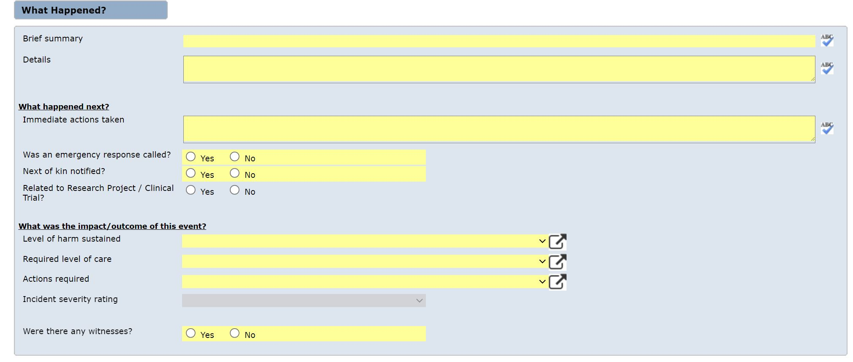

Tick “Yes” if event is related to research.

Tick “No” if event is not related to research or unsure.

Provide one sentence summary of what happened

Enter further details known about the event

Describe immediate actions taken. For example, “Called staff”

Use drop down menus to select most appropriate response.

.